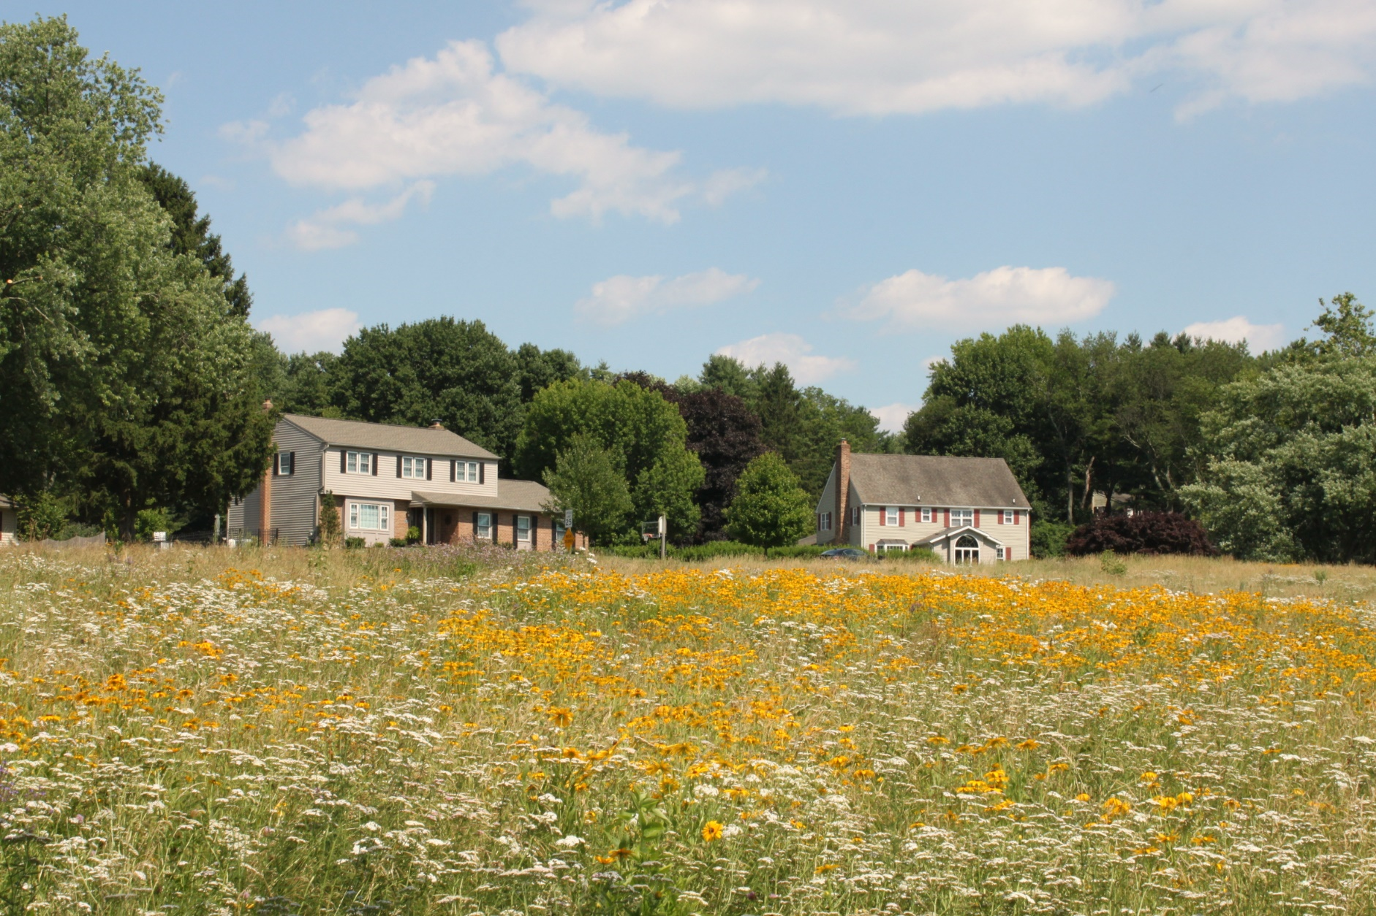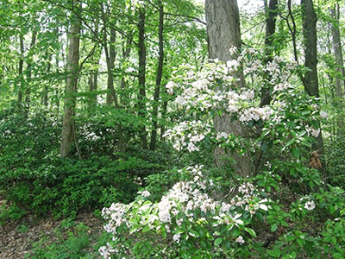

## **Model Action Items for:**

## Stormwater Management

## Solar and Energy Efficiency

## Sustainable Landscaping

## Tree Canopy and Woodland Stewardship

## Water Quality and Riparian Buffers

## Waste Reduction, Recycling, Composting

## Sustainable Transportation

## Historic Preservation

## Organization, Governance, and Communication

October 2, 2024

**Sustainability Action Plan Template**

# Homeowners Associations

Chester County, PA

Actions, Resources, and Partners to Advance Sustainable Practices